Session 9: SQL Built-in Functions for Data Cleaning
1. Objective
To utilize built-in string and mathematical functions to normalize user data, generate default credentials, and perform department-level analysis.

2. Implementation Queries
Task 1: Generate Default Password
Extract the portion of the email before the "@" symbol and append "123" to create a default login password.
SELECT Email, CONCAT(SUBSTRING_INDEX(Email, '@', 1), '123') AS Default_Password
FROM Student;
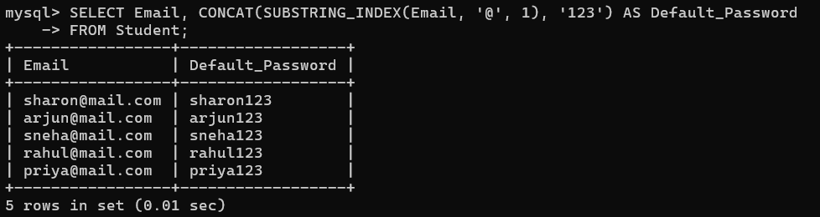
Task 2: Clean Invalid Contact Numbers
Remove spaces, dashes, or symbols from phone numbers to keep only the numeric digits.
SELECT Phone, REGEXP_REPLACE(Phone, '[^0-9]', '') AS Cleaned_Phone
FROM Student;
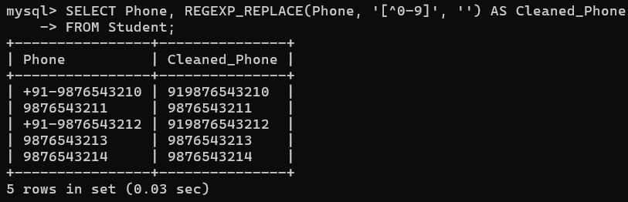
Task 3: Normalize Names
Ensure all student names are consistently formatted (e.g., all Uppercase) regardless of how the user typed them.
SELECT Name, UPPER(Name) AS Normalized_Name FROM Student;
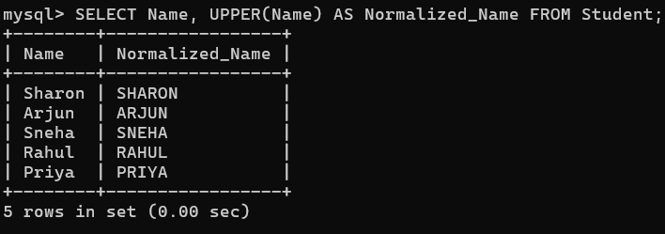
Task 4: Handle Missing Contact Data
Use COALESCE to find the first available contact method for a student, prioritizing Phone over Email.
SELECT Name, COALESCE(Phone, Email, 'No Contact Info') AS Primary_Contact
FROM Student;
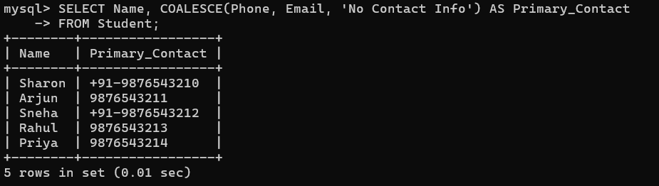
Task 5: Department Analysis
Calculate the average number of projects (represented here by the count of entries in the Course table) per department.
SELECT s.Department, AVG(c.Faculty_Id) AS Avg_Faculty_Assigned
FROM Student s
JOIN Course c ON s.VTU_Number = c.Student_ID
GROUP BY s.Department;
